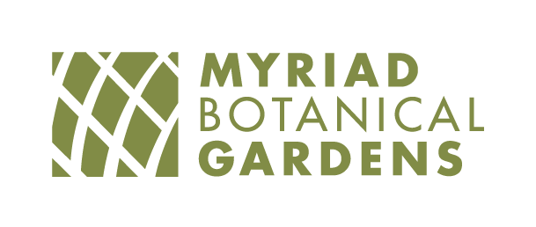

Park Management foundation

Job Description

FLSA Status: Non-exempt
Job Title: Membership & Donor Database Manager
Reports to: Director of Development
Work Schedule: Full Time with Benefits; 40-hour per
week. Includes regular evening, weekend, and daytime office hours as needed.

Summary
The Membership & Donor Database Manager (MDMM) plays a central role in driving membership growth, engagement, and retention while ensuring the integrity and strategic use of the organization’s CRM system (Altru). This position blends strong technical database experience with a proactive, people-centered approach to membership, equipping staff with the tools, training, and insights needed to grow and sustain a vibrant membership community.

The MDMM is both a systems expert and internal leader who builds capacity across the organization, training and supporting staff to confidently promote, sell, and steward memberships. This role is essential in creating a culture of membership, ownership, accountability, and enthusiasm regarding the Foundation’s robust membership program.

As the organization’s primary donor database and membership systems expert, the MDMM serves as a key partner across teams, ensuring seamless coordination between data, operations, and membership engagement efforts. This role requires a detail-oriented, systems-savvy professional who is equally comfortable in the backend of database management and in front-line support of staff training and member-facing processes. The ideal candidate thrives in a fast-paced, collaborative environment and brings both technical precision and a proactive approach to strengthening membership growth, retention, and overall engagement.

Essential Duties and Responsibilities:

- Serve as an internal leader and trainer for membership across departments, ensuring all staff understand, value, and actively promote membership.
- Develop and deliver training on donor database use, membership sales techniques, and stewardship best practices.
- Partner with marketing, events, and frontline staff to integrate membership into all visitor touchpoints.
- Identify opportunities to increase membership acquisition, upgrades, and renewals through data-informed strategies.
- Foster excitement and energy around membership internally and externally.
- Serve as a key point of contact for members, donors, and the public.
- Respond to inquiries with a high level of professionalism and service.
- Collaborate across teams to ensure a seamless and positive member experience.
- Maintain and ensure the integrity, accuracy, and usability Altru for donor’s records.
- Ensure clear processes and standards for data entry, reporting, and usage across teams.
- Oversee accurate and timely processing of memberships, donations, and pledges.
- Ensure prompt, personalized acknowledgements and tax receipts.
- Segment audiences and generate targeted lists for campaigns, events, and communications.
- Build and maintain dashboards and reports that track membership performance, revenue, retention, and engagement.
- Analyze trends and provide actionable insights to inform strategy and decision-making.
- Other duties as assigned.

Supervisory Responsibilities
This position has no supervisory responsibilities.

Education and/or Experience
- Bachelor’s degree is preferred, or equivalent
- A minimum of two years of related experience in a database administrative position including nonprofit and fundraising.

Certificates, Licenses, Registrations
- Valid Oklahoma Driver’s License.

Computer Equipment and Software Requirements
- Intermediate to advanced skills in Microsoft Office, particularly Word and Excel, and standard office equipment.
- Social media management desired

Knowledge, Skills and Abilities Required
- Excellent oral and written communication skills.
- Excellent organization and customer service skills.
- Ability to stay calm under pressure.
- Commitment to excellent customer service and membership experience.
- Strong analytical skills with the ability to translate data into strategy and action.
- Must present professional appearance and a positive, enthusiastic attitude.
- Must be able to multi-task, return all emails and phone calls in a timely manner and work well in a team atmosphere.

Physical Requirements
- Must be able to sit or stand for extended periods.
- Must be able to bend, stoop and lift on occasions.
- Must be able to climb stairs.
- Must be able to lift and push event equipment, i.e., tables, chairs, audio visual equipment, chair and table carts.

Additional Job Requirements
Clearance of background check.

Work Environment
The employee will work in both an office and botanical gardens environment. There are locations visited while executing job duties that may not be wheelchair accessible; some time may be spent outside in various weather conditions.
The qualifications, physical demands, and work environment described herein are representative of those an employee will encounter and must meet to successfully perform the essential functions of this job. Reasonable accommodation may be provided to enable individuals with disabilities to perform the essential functions. The requirements listed in this document are the minimum levels of knowledge, skills, or abilities.
This document does not create an employment contract, implied or otherwise, other than an "at will" relationship.
Equal Opportunity Employer: Employer does not to discriminate against any employee or job applicant because of race, color, religion, national origin, sex, physical or mental disability, or age.

I acknowledge that I have read and understand this job description.

Employee signature Date

